Mobile Site Accessibility Testing Methodology – Test Cases for Assistive technologies and mobile features

# Table of Contents

Table of Contents 2

Table of Figures 6

Introduction 9

Why this is important 9

Errors that need to be tested 9

iOS combinations 9

iPhone 9

iPad 9

Android combinations 10

9. iOS Test Cases 11

9.1: VoiceOver (iOS) 11

About this requirement 11

How to test 11

Examples 12

9.2: Keyboard (iOS) 13

About this requirement 13

How to test 13

Examples 13

9.3: Switch (iOS) 15

About this requirement 15

How to test 15

Examples 16

9.4: Zoom (iOS) 17

About this requirement 17

How to test 18

Examples 18

9.5: Reduce motion (iOS) 19

About this requirement 19

How to test 19

Examples 19

9.6: Invert colors (iOS) 20

About this requirement 20

Classic Invert 20

Smart Invert 20

How to test 21

Examples 21

9.7: Grayscale (iOS) 23

About this requirement 23

How to test 23

Examples 23

9.8: Reader view and increase text size (iOS Safari) 25

About this requirement 25

How to test 26

Examples 26

10. Android test cases 28

10.1: TalkBack (Android) 29

About this requirement 29

How to test 29

Examples 29

10.2: Keyboard (Android) 30

About this requirement 30

How to test 30

Examples 30

10.3: Switch (Android) 31

About this requirement 31

How to test 32

Examples 32

10.4: Magnification (Android) 34

About this requirement 34

How to test 34

Examples 34

10.5: Remove animations (Android) 35

About this requirement 35

How to test 35

Examples 35

10.6: Color inversion (Android) 36

About this requirement 36

How to test 36

Examples 36

10.7: Grayscale (Android) 36

About this requirement 37

How to test 37

Examples 37

10.8: Color correction (Android) 38

About this requirement 38

How to test 39

Examples 39

10.9: Increase display size (Android) 40

About this requirement 40

How to test 40

Examples 40

10.10: Increase text size (Android Chrome) 42

About this requirement 42

How to test 42

Examples 42

10.11: Simplified view 44

About this requirement 44

How to test – Android Chrome 45

Examples – Simplified view (Android) 45

7. Samsung test cases 48

7.1: Voice assistant for Samsung (Samsung) 48

About this requirement 48

How to test 48

Examples 48

8. Kindle test cases 49

Help for Kindle 49

12.1: VoiceView for Kindle (Kindle) 49

About this requirement 49

How to test 49

Examples 49

Acknowledgements 51

Relationship to existing Accessibility testing standards 51

ICT Accessibility Testing Symposium Mobile Site Sub-Committee 51

Contacts 51

Gian Wild 51

Peter McNally 51

# Table of Figures

Figure 1: Turning on VoiceOver on iOS 10

Figure 2: Setting Accessibility shortcuts on iOS 10

Figure 4: All content is read by VoiceOver 11

Figure 6: Keyboard accessible 12

Figure 7: Keyboard accessible 13

Figure 9: Actionable element can be navigated to and activated with Switch 15

Figure 10: Activating zoom on iOS 16

Figure 15: Zoom enlarges the screen 17

Figure 18: Reduce Motion stops moving content (normal view) 18

Figure 19: Reduce Motion stops moving content (with reduced motion) 18

Figure 20: Activating Classic Invert on iOS 19

Figure 21: Classic Invert on iOS activated 19

Figure 22: Activating Smart Invert on iOS 19

Figure 23: Smart Invert on iOS activated 19

Figure 24: Classic Invert 20

Figure 25: Grayscale view on iOS 22

Figure 26: Grayscale 23

Figure 27: Grayscale activated 23

Figure 28: Turning on the Reader view on iOS 24

Figure 29: The same article displayed in Reader view 24

Figure 30: Increase text size (smaller text) 25

Figure 31: Increase text size (larger text) 25

Figure 34: Reader view (normal view) 25

Figure 35: Reader view 25

Figure 36: Reader View increase text size (smallest text) 26

Figure 37: Reader View increase text size (largest text) 26

Figure 38: Support link in the Font Size page 27

Figure 39: Font size support 27

Figure 40: Selecting Settings in the TalkBack page 28

Figure 41: The TalkBack tutorial 28

Figure 43: Keyboard accessible with highly visible keyboard focus indicator 29

Figure 44: The Settings link in the Switch Access page 30

Figure 45: Switch Access Settings 30

Figure 47: Actionable element can be navigated to and activated with switch 31

Figure 49: Color inversion (normal view) 35

Figure 50: Color inversion (activated) 35

Figure 51: Selecting different color blindness options 37

Figure 52: Color blindness options 37

Figure 53: Color Correction off 37

Figure 54: Color Correction on 37

Figure 57: Content increases in display size (normal display size) 39

Figure 58: Content increases in display size (largest display size) 39

Figure 59: Content increases in display size (normal display size) 40

Figure 60: Content increases in display size (largest display size) 40

Figure 61: Android text scaling options 41

Figure 66: All text increases in size (normal text size) 41

Figure 67: All text increases in size (200% text size) 41

Figure 68: Vertical ellipsis menu button in Chrome 43

Figure 69: Chrome dropdown menu 43

Figure 70: "Show simplified view" option 43

Figure 71: Simplified view activated 43

Figure 74: Simplified view available (normal view) 44

Figure 75: Simplified view available (activated) 44

Figure 76: Simplified view available (normal view) 45

Figure 77: Simplified view available (activated) 45

Figure 78: Simplified view can be used 46

Figure 79: Content read by VoiceView 48

# Introduction

## Why this is important

Mobile devices provide a multitude of accessibility features. As an accessibility tester for mobile devices, it is important that you understand what these features are, how they work, and how they improve an experience for someone with a given disability. As both mobile operating systems and mobile assistive technology are structured in a different manner from their desktop counterparts, it is important that mobile testing is conducted independently from desktop testing of a website. As a rule of thumb, if a website is not compatible with assistive technology designed for the device with which you are testing, it is inaccessible.

Essential content should never be hidden from assistive technology but displayed visually. An example of this would be to use aria-hidden=“true”, which causes the element to be ignored by assistive technology. For more information see [WCAG2.1 SC 1.1.1: Non-text Content](https://www.w3.org/WAI/WCAG21/Understanding/non-text-content). In addition, aria-hidden=“true”, CSS display:none, and CSS visibility can be used to “hide” other content on a page from assistive technology. If this content is meaningful, it should be available to assistive technology.

Any control that changes a state visually should indicate the change of state to the assistive technology user. For example, a hamburger menu that is closed would show an aria-expanded=“false”, and when opened, it would show aria-expanded=“true”. A ratings star that turns yellow when the user selects it should tell the assistive technology user of the change to yellow. For more information see [WCAG2.1 SC 4.1.2: Name, Role, Value](https://www.w3.org/WAI/WCAG21/Understanding/name-role-value).

## Errors that need to be tested

#### Access and activation

All actionable items and content can be accessed and activated by the following assistive technologies (or when the following feature is enabled):

Please see the following sections on how to test this requirement with assistive technologies and mobile features.

## iOS combinations

Please note that iOS 13 features, such as Dark Mode and Voice Control are not included in this list. Please note: As of July 2019, “dynamic type” on iOS does not change the appearance of web pages in Safari.

### iPhone

* VoiceOver
* Keyboard
* Keyboard and switch
* Zoom
* Invert colors
* Grayscale
* Reader view

### iPad

* VoiceOver
* Keyboard
* Keyboard and switch
* Zoom
* Invert colors
* Grayscale
* Reader view

## Android combinations

* TalkBack
* Voice Assistant (Samsung)
* VoiceView (Kindle)
* Keyboard
* Keyboard and switch
* Magnification
* Invert colors
* Grayscale
* Increase text size with Android Chrome
* Color correction
* Simplified view

# 9. iOS Test Cases

Please note that the committee is aware that Assistive Touch, as well as other iOS 13 features bring a myriad of advances for people with disabilities. The committee will be reviewing these assistive technologies in the coming year.

## 9.1: VoiceOver (iOS)

All actionable items and content can be accessed and activated by VoiceOver on iOS.

### About this requirement

VoiceOver users include blind and low-vision users, as well as users with some cognitive or learning difficulties. To enable VoiceOver, navigate to **Settings** → **General** → **Accessibility** → **VoiceOver.**

Then, tap and slide the white **Off** button (beside the word *VoiceOver*) to the right to enable VoiceOver. Once in the On position, the button changes color to indicate VoiceOver is enabled.

|  |  |
| --- | --- |
| Figure 1: Turning on VoiceOver on iOS  Screenshot of iOS VoiceOver view and toggle. | Figure 2: Setting Accessibility shortcuts on iOS  Screenshot of iOS Accessibility shortcuts view. |

You may find it easier to toggle VoiceOver by setting the “Accessibility Shortcut” to VoiceOver and/or the other accessibility options. Once set up, triple-click the home or side button of the device to enable the menu. (If only one accessibility setting is enabled, the device won’t show a menu and will immediately toggle the setting.)

### How to test

1. Open Safari and launch the website.
2. Scan the page for content and actionable items.
3. Turn on VoiceOver.
4. Utilize standard navigation techniques for VoiceOver to browse the page. Whilst VoiceOver is robust, common controls to get started include:
   1. Move forward by swiping right with one finger to read the next piece of content on the page. Swiping left moves you backward. Note: This means that you will no longer have traditional swipe functionality.
   2. To select a link, form field, or other actionable item, double tap the screen with one finger.
   3. There are many [additional gestures used to control VoiceOver](https://support.apple.com/guide/iphone/learn-voiceover-gestures-iph3e2e2281/12.0/ios/12.0), including a useful [rotor tool](https://support.apple.com/en-us/HT204783) that allows users to browse by headings, regions, form fields, etc. at the users’ pleasure.
5. Verify that all content can be read by VoiceOver and that the text being read by VoiceOver matches what is on screen.
6. Verify that all actionable items can be accessed and controlled by VoiceOver. It is imperative that all actionable items are accurately labelled and described.

### Examples

#### Pass 1 – All content is read by VoiceOver

On this site, all content can be read, and all actionable items have appropriate descriptions and function as expected with VoiceOver controls

Figure 4: All content is read by VoiceOver

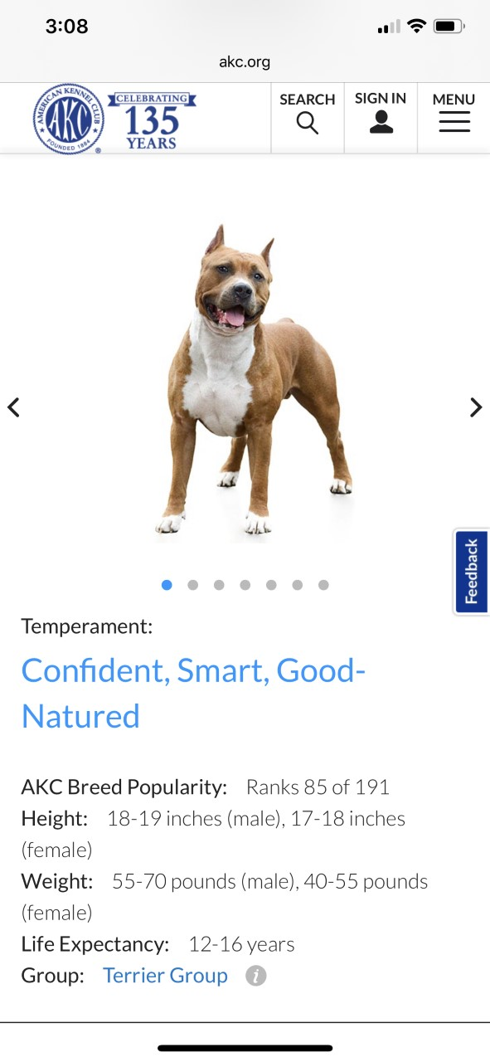

## 9.2: Keyboard (iOS)

All actionable items and content can be accessed and activated by the keyboard on iOS.

### About this requirement

iOS 12.3 and lower only support keyboard use when VoiceOver is activated. Apple is projecting that iOS 13 will support keyboard use without VoiceOver.

Connect a Bluetooth keyboard to your iOS device, activate VoiceOver, and navigate to the page in Safari as you would on desktop. Press the arrow keys or TAB to navigate from one actionable item (buttons, links and form controls) to the next, use SPACEBAR or ENTER to activate the currently selected item.

### How to test

1. Connect the keyboard. Turn on VoiceOver
2. Do all actionable items receive focus when using the TAB or arrow keys?
3. Can all actionable items be activated?
4. Can the keyboard access all fields, radio buttons, checkboxes, dropdowns and submit buttons?
5. Is the keyboard focus visible at all times?
6. Is the keyboard focus indicator highly visible?
7. Do items receive keyboard focus in the order that they visibly appear on the screen?

### Examples

#### Pass 1 – Keyboard accessible

The Washington Post menu is keyboard accessible and has a highly visible keyboard focus indicator (please note that this does not have a keyboard focus indicator in Android).

|  |  |
| --- | --- |
| Figure 6: Keyboard accessible  Screenshot of Washington Post article. |  |

#### Pass 2 – Keyboard accessible

The ABC menu is keyboard accessible and has a highly visible keyboard focus indicator.

|  |  |
| --- | --- |
| Figure 7: Keyboard accessible  Screenshot of ABC opened menu. "Radio" menu link is receiving focus. |  |

## 9.3: Switch (iOS)

All actionable items and content can be accessed and activated by the switch on iOS.

### About this requirement

In most cases switch errors will be identified also as keyboard errors. This will be investigated more fully in the coming year.

People with limited manual dexterity or other mobility disabilities often use Switch Control. Switch Control allows users to navigate their phone with one or more switches. To enable Switch Control, navigate to **Settings** → **General** → **Accessibility** → **Switch Control.**

Switch Control has two modes: item mode and point mode. Item mode will scan through groups of elements on the screen. Each time a user activates the Select Item switch, it will drill down into that group of elements. Once an element is selected, the options to Tap the element or access the switch menu appears. When an element cannot be accessed using item mode, point mode can be used. Point mode allows the user to select a location on screen to simulate a tap through a coordinate grid system. Users select the vertical location and then the horizontal location of where they would like to tap. Point mode is much more tedious to use than item mode. Switch Control also has more advanced features available (for example: simulating gestures).

Users typically use one or two switches. A variety of hardware options are available to use as a switch: Bluetooth switch, Bluetooth keyboard, sip and puff technology, wheelchair joystick and other switches. The iOS device’s screen can also be used as a switch. For testing, it is easiest to use a Bluetooth keyboard. Each key can be programmed as a different switch action. Note that the original actions of the switch (device’s screen or hardware button) will be overrode by the switch’s action.

Each switch is mapped to a specific action. The action that is easiest to use for testing is Select Item. The Select Item action will scan through items on screen with either item mode or point mode, access the Tap feature and the switch menu. A second switch action that is popular is Scanner Menu, which provides the user with easier access to the switch’s menu.

To set up the device’s screen as a switch: navigate to **Settings** → **General** → **Accessibility** *→* **Switch Control *→* Switches *→* Add New Switch… *→ Screen* *→* Full Screen** *→* **Select Item.**

The switch’s item mode navigates to both actionable and nonactionable elements. Most of the time, nonactionable elements do not need to be accessed if they are visible in the current screen view. Scrolling is also an important feature to test in order to access content. Scrolling can be accessed on the switch’s menu.

### How to test

1. Activate the switch (or the screen)
2. Scan to the section you want to navigate to and activate the switch
3. Repeat step 2 until you drill down to an element. When an element is activated, a menu will appear.
4. Activate the Tap menu item.
5. If the element is not accessible via item mode, point mode is a fallback/workaround. Item mode must work for an item to pass. To use point mode:
   1. Repeat steps 1-4 of item mode above to drill down to an element. When an element is activated, a menu will appear.
   2. Activate the ".." under Tap to access more menu features.
   3. Activate the row with Point Mode, then activate Point Mode
   4. A grid will appear to allow you pick where on the screen to simulate a "tap"
   5. Select the horizontal area of the screen and then the vertical area of the screen
   6. Select the horizontal and vertical point to simulate a "tap"
   7. Activate the Tap menu item.

### Examples

#### Pass 1 – Actionable element can be navigated to and activated with Switch

The actionable element can be navigated to or activated using item mode. The link below is selected with item mode.

|  |  |
| --- | --- |
| Figure 9: Actionable element can be navigated to and activated with Switch  Screenshot of Google homepage. Link "see how little elves have a big impact" is selected. A popup gives the options "Tap," "Zoom In," "Zoom Out," and "Scroll Down" |  |

## 9.4: Zoom (iOS)

All actionable items and content can be accessed and activated with Zoom enabled on iOS.

### About this requirement

People with low vision often use Zoom. Users with cognitive impairments, such as autism or attention deficit disorder, may also use Zoom to focus in on key content and reduce the amount of visual clutter on the screen. To enable full screen Zoom, first navigate to the Zoom screen and select **Settings** → **General** → **Accessibility** → **Zoom.**

Then, touch and slide the white **Off** button (beside the word *Zoom*) to the right to enable Zoom. Once in the On position, the button changes color to indicate Zoom is enabled.

Triple-tapping the screen with three fingers will display the Zoom menu. You can adjust the following settings with the Zoom menu:

* Choose Region: select Full Screen Zoom or Window Zoom.
  + Full Screen Zoom: You can magnify the entire screen
  + Window Zoom: Magnify only part of the screen with a resizable lens. You can move the lens around to zoom in on different sections of the screen.
* Choose Filter: select Inverted, Grayscale, Grayscale, or Low Light.
* Show/Hide the Controller: show/hide the zoom controller. The Zoom controls provides a quick way to pan the screen or zoom in or out.
* Use the slider to control the zoom level.

Figure 10: Activating zoom on iOS



Standard iOS gestures—flick, pinch, tap and rotor—still work when the screen is magnified. Invert Colors and Grayscale also work with Zoom. There are some differences in commands when Zoom is run with VoiceOver.

You can view magnified screens either in either “Full Screen Zoom” or “Window Zoom.”

### How to test

1. Triple tap with three fingers to open the zoom menu.
2. Select a region (Full Screen or Window).
3. Select a zoom magnification.
4. Select a Filter
5. Determine that you can move around the page and access all content and functionality.

### Examples

#### Pass 1 – Zoom enlarges the screen

|  |  |
| --- | --- |
| Figure 15: Zoom enlarges the screen  Screenshot of Zoomed in portion of inc.com. |  |

## 9.5: Reduce motion (iOS)

Reduce Motion does not work on iOS, or content is lost when it is enabled.

### About this requirement

The Reduce Motion feature on iOS reduces swipe-in features and things like parallax scrolling. The Reduce Motion option is available under **Settings** → **General** → **Accessibility** → **Reduce User Motion**.

### How to test

1. Identify all areas of movement in the site.
2. Turn on the Reduce Motion feature.
3. Is the movement removed or reduced?
4. Ensure no information or functionality is lost.

### Examples

#### Pass 1 – Reduce Motion stops moving content

With Reduce Motion enabled the “Window Wonderland” does not have any movement on loading the page. Normally the background shows people walking around.

|  |  |
| --- | --- |
| Reduce Motion disabled | Reduce Motion enabled |
| Figure 18: Reduce Motion stops moving content (normal view)  Screenshot of page reading "Window Wonderland." Image in the background of people walking on a street. | Figure 19: Reduce Motion stops moving content (with reduced motion)  Screenshot of page reading "Window Wonderland." Image in the background is of a stationary store window. |

## 9.6: Invert colors (iOS)

All actionable items and content can be accessed and activated with Invert Colors enabled on iOS.

### About this requirement

To enable Invert Colors, first navigate to **Settings → General → Accessibility → Display Accommodations** and find **Invert Colors** in the Vision list.

Then, tap the white **Off** button (beside the words *Invert Colors orClassic Invert*) to enable the feature. In the new page choose “Smart Invert” or “Classic Invert” as required. The color inversion is applied to all screens until the feature is disabled by switching the button to the **Off** position.

Invert Colors can be used with VoiceOver, Zoom and Grayscale.

### Classic Invert

Classic Invert inverts everything on the screen. As you can see from the invert screen, some items are difficult to see in Invert Colors – such as the native switch.

|  |  |
| --- | --- |
| Figure 20: Activating Classic Invert on iOS  iOS Invert Colors menu. Text is black on white and gray. Smart Invert and Classic Invert are turned off. | Figure 21: Classic Invert on iOS activated  iOS Invert Colors menu. Text is white on black. Classic Invert is turned on and the switch is black on purple. |

### Smart Invert

“Smart Invert,” a recent addition to iOS, will invert the colors of text and solid backgrounds while preserving the colors of graphics, media, and some mobile sites that support dark mode. When enabled, images on your site should not be inverted so that they remain clear and consistent.

As you can see from the invert screen, native switches are much easier to see in Smart Invert than in Classic Invert.

|  |  |
| --- | --- |
| Figure 22: Activating Smart Invert on iOS  iOS Invert Colors menu. Text is black on white and gray. Smart Invert and Classic Invert are turned off. | Figure 23: Smart Invert on iOS activated  iOS Invert Colors menu. Text is white on black. Smart Invert is turned on and the switch is white on green. |

### How to test

1. Open the site.
2. Activate Classic Invert.
3. Is the contrast between the foreground and background sufficient for important content and actionable items?
4. Ensure that no important content or actionable items use color as critical to its meaning.
5. Turn off Classic Invert.
6. Identify images, videos, camera access, dark backgrounds in the site.
7. Turn on Smart Invert.
8. Does the page show inverted colors, with the exception of images, videos, camera access and dark backgrounds?

### Examples

#### Pass 1 – Classic Invert

All content in the website inverts colors.

|  |  |
| --- | --- |
| Figure 24: Classic Invert  Screengrab of Kennedy-Center.org. All text and image content is color inverted. |  |

## 9.7: Grayscale (iOS)

All actionable items and content can be accessed and activated with Grayscale enabled on iOS.

### About this requirement

To enable Grayscale, first navigate to **Settings** → **General** → **Accessibility** → **Display Accommodations.** Select **Color Filters** and **t**oggle **Color Filters** to the **On** position. **Grayscale** is listed as the first color filter in the list and should be checked (on) by default. If not, select Grayscale so it is checked. Once Grayscale is enabled colors across iOS and all mobile sites are in grayscale.

Figure 25: Grayscale view on iOS

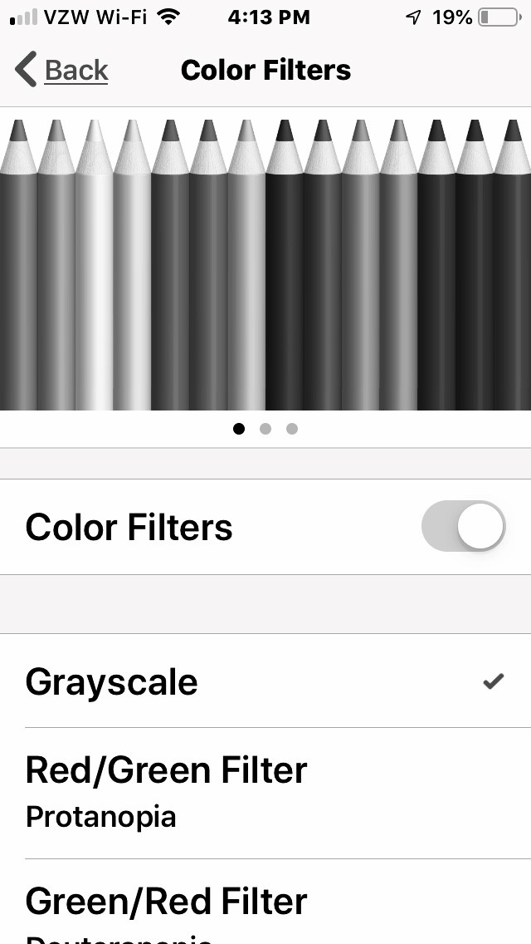

Grayscale is applied to all screens until the feature is disabled by toggling the button to the **Off** position. Grayscale can be used with VoiceOver, Zoom and Invert Colors.

### How to test

1. Open the site.
2. Activate Grayscale.
3. Is the contrast between the foreground and background sufficient for important content and actionable items?
4. Ensure that no important content or actionable items use color as critical to its meaning.

### Examples

#### Pass 1 – Grayscale

The entire site changes to Grayscale.

|  |  |
| --- | --- |
| Normal display | Grayscale display |
| Figure 26: Grayscale  Screenshot of Monash University webpage. | Figure 27: Grayscale activated  Screenshot of Monash University webpage in grayscale. |

## 9.8: Reader view and increase text size (iOS Safari)

All actionable items and content can be accessed and activated with Reader View and increase text size enabled on iOS Safari.

### About this requirement

The Larger Text Accessibility feature found in iPhones does not apply to Safari in iOS 12 and below. For iOS version 13.x, you may increase the text size for Safari in the Safari application settings.

Safari appears to rely on many structural elements to orient itself to the main content of the page. When clicked, the view should display the heading and content of the “main” part of the page, defined broadly, excluding any navigational elements other than “next” and “previous” at the end of the page or post.

If you find that the Reader view does not capture the main content of the page, check for the presence of structural tags such as <main>.

For iOS version 12.3 and lower, you must do the following on Safari:

1. Open the web page in the browser.
2. If text size on that page can be increased Safari will display “Reader View” in the URL area and then an icon appearing as several horizontal lines on the left. Not all pages have “Reader View” available.
3. Tap the lines icon. An “AA” icon appears in the top-right of the URL area.
4. Tap on the “AA” to open a menu.
5. Increase or decrease the text size by tapping on the large A or small A.

When Safari has enough information to create a reader view, you can see the Reader view icon to the left of the domain name (URL) at the top of the screen.

|  |  |
| --- | --- |
| Figure 28: Turning on the Reader view on iOS  Screenshot of washingtonpost.com on iOS Safari browser showing a button to the left of the URL that can change the view to Reader View | Figure 29: The same article displayed in Reader view  Screenshot of washingtonpost.com on iOS Safari browser showing the Reader View activated |

When Reader View is available you can select the “AA” option in the top right to modify text size and color.

|  |  |
| --- | --- |
|  |  |
| Figure 30: Increase text size (smaller text)  Screenshot of text color, size and font menu opened. The page text is default size. | Figure 31: Increase text size (larger text)  Screenshot of text color, size and font menu opened. The page text is a larger size. |

### How to test

For iOS version 13.x, you may increase the text size for Safari in the Safari application settings.

For iOS version 12.3 and lower, you must do the following on Safari:

1. Identify all pages with one main block of text.
2. Is the Reader view available?
3. If the Reader view is available, tap the lines icon. Does the content change to Reader view?
4. Tap on the “AA” to open a menu.
5. Increase or decrease the text size by tapping on the large A or small A.
6. Does the text change size appropriately?
7. Ensure that extraneous content is not shown, and the only content visible is the main block of content (with headings)
8. Ensure the text does not overlap or obstruct other elements on the page.

### Examples

#### Pass 1 – Reader View

On this site, the Reader view displays just the article text.

|  |  |
| --- | --- |
| Normal View | Reader View |
| Figure 34: Reader view (normal view)  Screenshot of movieweb.com showing a featured image, an article and an ad. | Figure 35: Reader view  Screenshot of movieweb.com in Reader View showing only the article text. |

#### Pass 2 – Reader View increase text size

In this page, the text changes size appropriately.

|  |  |
| --- | --- |
| Smallest text | Largest text |
| Figure 36: Reader View increase text size (smallest text)  Screengrab of article on Google. Text is default size. | Figure 37: Reader View increase text size (largest text)  Screengrab of article on Google. Text is much larger than default. |

# 10. Android test cases

In general, you access assistive technologies and mobile features through the **Settings** menu, and then select **Accessibility**. In most cases you can access detailed instructions by selecting the question mark icon in the top right-hand corner.

|  |  |
| --- | --- |
| Figure 38: Support link in the Font Size page | Figure 39: Font size support |
| Screengrab of sample text. The question mark icon is indicated. | Screenshot of Android Support menu. |

## 10.1: TalkBack (Android)

All actionable items and content can be accessed and activated by TalkBack on Android.

### About this requirement

To enable TalkBack, navigate to **Settings** → **Accessibility** → **TalkBack** then switch the button to **On**. A “Use TalkBack” confirmation screen will appear. When used for the first time a tutorial will be launched. Ensure the device volume is turned up as TalkBack doesn’t automatically adjust the volume if muted. See the [Android documentation on getting started on Android with TalkBack](https://support.google.com/accessibility/android/answer/6283677?hl=en).

You can also access additional information and a detailed TalkBack tutorial by selecting **Settings.**

|  |  |
| --- | --- |
| Figure 40: Selecting Settings in the TalkBack page | Figure 41: The TalkBack tutorial |
| Screenshot of Android TalkBack screen. The "Settings" link is indicated. | Screenshot of Android TalkBack Settings menu. |

### How to test

1. With TalkBack on, open the site.
2. Swipe through the site.
3. As you swipe, the content will be read out loud.
4. Verify that all content can be read by TalkBack and that the text being read by TalkBack matches what is on screen.
5. Verify that all actionable items can be accessed and controlled by TalkBack. It is imperative that al actionable items are accurately labelled and described.

### Examples

#### Pass

There are currently no example passes documented for this requirement. Similar Pass examples are available in the Mobile Site Assistive Technologies and Mobile Features Test Cases document.

## 10.2: Keyboard (Android)

All actionable items and content can be accessed and activated by the keyboard on Android.

### About this requirement

Connect a Bluetooth keyboard to your Android device and navigate the page in Chrome as you would on desktop. Press TAB to navigate from one actionable item (buttons, links and form controls) to the next, use SPACEBAR to scroll the page, and press ENTER to activate the currently selected item.

### How to test

1. Connect the keyboard.
2. Do all actionable items receive focus when using the TAB or arrow keys?
3. Can all actionable items be activated using Enter?
4. Can the keyboard access all fields, radio buttons, checkboxes, dropdowns and submit buttons?
5. Is the keyboard focus visible at all times?
6. Is the keyboard focus indicator highly visible?
7. Do items receive keyboard focus in the order that they visibly appear on the screen?

### Examples

#### Pass 1 – Keyboard accessible with highly visible keyboard focus indicator

In The Washington Post website, the menu items are keyboard accessible and have a highly visible keyboard focus indicator.

|  |  |
| --- | --- |
| Figure 43: Keyboard accessible with highly visible keyboard focus indicator  Screenshot of a Washington Post webpage with navigation menu open. "Opinions" link is receiving focus. |  |

## 10.3: Switch (Android)

All actionable items and content can be accessed and activated by the switch on Android.

### About this requirement

To enable switch access, navigate to **Settings** → **Accessibility** → **Switch access** and then switch the button to **On**.

Switch Access has two modes: item mode and point scan mode. Item mode will scan through the elements on the screen. Once an element is selected, the options to Tap the element or access the switch menu appears. When an element cannot be accessed using item mode, point mode can be used. Point scan mode allows the user to select a location on screen to simulate a tap through a coordinate grid system. Users select the vertical location and then the horizontal location of where they would like to tap. Point mode is much more tedious to use than item mode. The menu for Switch Access is at the top of the screen and can be used to access scrolling, switch modes and access device functions.

Users typically use one or two switches. A variety of hardware options are available to use as a switch: Bluetooth switch, Bluetooth keyboard, sip and puff technology, wheelchair joystick and other switches. For testing, it is easiest to use a Bluetooth keyboard. Each key can be programmed as a different switch action.

To use switch access, you’ll need a keyboard paired with the tablet or mobile. Then you’ll need to assign keys to actions through **Settings** → **Accessibility** → **Switch access** → **Settings**. Select **Assign switches for scanning** under the heading “**Assign switches**” to map a keystroke to the action. Mapping “Auto-scan” and “Enter” actions is recommended. Note that the keys that you map to actions will no longer have their original action. The on-screen keyboard may not appear by default. To enable the on-screen keyboard: **Settings → General Management → Language and input → Physical keyboard → toggle Show on-screen keyboard to On**.

The switch’s item mode navigates to both actionable and nonactionable elements. Most of the time, nonactionable elements do not need to be accessed if they are visible in the current screen view. Scrolling is also an important feature to test in order to access content. Scrolling can be accessed on the switch’s menu or activating an area of the screen via item mode.

If the on-screen keyboard is not working properly with Switch Access, check that your on-screen keyboard is enabled and use the GBoard keyboard if the default keyboard doesn’t behave correctly.

|  |  |
| --- | --- |
|  |  |
| Figure 44: The Settings link in the Switch Access page  Screenshot of the Android Switch Access screen. "Settings" link is indicated. | Figure 45: Switch Access Settings  Screenshot of the Android Switch Access settings screen. |

### How to test

1. Activate the switch (or the screen)
2. Scan to the section you want to navigate to and activate the switch
3. Activate the Tap menu item.
4. If the element is not accessible via item mode, point scan mode is a fallback/workaround. Item mode must work for an item to pass. To use point scan mode:
   1. Activate the Menu button to access the menu
   2. Activate the Point Scan Mode
   3. A grid will appear to allow you pick where on the screen to simulate a "tap"
   4. Select the horizontal area of the screen and then the vertical area of the screen
   5. Select the horizontal and vertical point to simulate a "tap"

### Examples

#### Pass 1 – Actionable element can be navigated to and activated with switch

The actionable element can be navigated to or activated using item mode. The link below is selected with item mode.

|  |  |
| --- | --- |
| Figure 47: Actionable element can be navigated to and activated with switch  A screenshot of Google's homepage and the "See how little elves have a big impact" link is selected with item mode. |  |

## 10.4: Magnification (Android)

All actionable items and content can be accessed and activated with Magnification enabled on Android.

### About this requirement

To enable Zoom, navigate to **Settings** → **Accessibility** → **Magnification.** There are two settings, one for **Magnify with a Triple Tap** (Off by default) and **Magnify with a Shortcut** (Off by default).

Choose **Magnify with a Triple Tap** or **Magnify with a Shortcut** by selecting the item and then turning on the Use service button **On**.

When magnification gestures are enabled, you can zoom, pan across the screen and pan content:

* **Zoom:** quickly tap the screen 3 times.
* **Adjust Zoom:** pinch with two or more fingers to adjust zoom.
* **Scroll:** drag two or more fingers to scroll.
* **Zoom temporarily:** quickly tap the screen three times and hold your finger down on the third tap.
* **Move around the screen:** drag.

Note: you can’t zoom in on the keyboard and navigation bar (native UI elements).

When magnify with button is on, you can use the Accessibility button at the bottom of the screen to quickly magnify. To zoom, tap the Accessibility button, then tap anywhere on the screen.

To zoom temporarily, tap the Accessibility button, then touch and hold on the screen. Drag to move around the screen. Lift finger to zoom out.

### How to test

1. Open the mobile site and turn on **Magnification**.
2. While zoomed in, can you:
   1. Drag two or more fingers to pan across the screen?
   2. Pinch two or more fingers together or spread them apart to adjust the zoom level?  
      Ensure the zoom is operable and there are no barriers and no element does not zoom accordingly (keyboard and navigation bar excepted).

### Examples

#### Pass

There are currently no example passes documented for this requirement. Similar Pass examples are available in the Native App Assistive Technologies and Mobile Features Test Cases document.

## 10.5: Remove animations (Android)

All actionable items and content can be accessed and activated with Remove Animations enabled on Android.

### About this requirement

The Remove Animations feature on Android reduces swipe-in features and things like parallax scrolling. To enable Remove Animations, navigate to **Settings** → **Accessibility** and turn on **Remove Animations** (off by default).

### How to test

1. Identify all areas of movement in the site.
2. Turn on the Remove Animations feature.
3. Is the movement removed or reduced?

### Examples

#### Pass

There are currently no example passes documented for this requirement.

## 10.6: Color inversion (Android)

All actionable items and content can be accessed and activated with Color Inversion enabled on Android.

### About this requirement

To enable Color Inversion, navigate to **Settings** → **Accessibility** → **Color Inversion** then switch the button to **On**. Simply tapping on the title “Color Inversion” or tapping the toggle switch will activate color inversion immediately. The background will invert from white to black, and colors for icons and text, invert accordingly.

### How to test

1. Open the site.
2. Activate Color Inversion.
3. Is the contrast between the foreground and background sufficient for important content and actionable items?
4. Ensure that no important content or actionable items use color as critical to its meaning.

### Examples

#### Pass 1 - Color Inversion

The ABC website the Color Inversion works.

|  |  |
| --- | --- |
| Figure 49: Color inversion (normal view)  Screenshot of the ABC homepage. | Figure 50: Color inversion (activated)  Screenshot of the ABC homepage with colors inverted. |

## 10.7: Grayscale (Android)

All actionable items and content can be accessed and activated with Grayscale enabled on Android.

### About this requirement

To enable Android’s grayscale view, first **enable Developer Mode** on your device. (This is a one-time process for each device.)

* Go to **Settings → About Tablet** (which might also be labelled “About Phone” or “About Device”).
* Locate the Build number section and tap on the phrase “Build number” 7 times.
* Go back to the main Settings page and tap on “Developer Options.”
* Enable the Developer Options switch.

From then on, you can enable Android ’s grayscale view (Lollipop 5.0 onwards) by going to **Settings** → **Developer Options** → **Simulate color space** and selecting “**Monochromacy**.” Once you’ve made that selection, display colors will be replaced by shades of gray.

Grayscale is applied to all screens until you turn off the feature, which you can do by going back to **Settings** → **Developer Options** → **Simulate color space** and selecting “**Disabled**.”

Android’s grayscale view can be used alongside any of Android’s other modes or applications, including TalkBack and Shade, among others.

### How to test

1. Open the site.
2. Activate Grayscale.
3. Is the contrast between the foreground and background sufficient for important content and actionable items?
4. Ensure that no important content or actionable items use color as critical to its meaning.

### Examples

#### Pass

There are currently no example passes documented for this requirement. Similar Pass examples are available in the Native App Assistive Technologies and Mobile Features Test Cases document.

## 10.8: Color correction (Android)

All actionable items and content can be accessed and activated with Color Correction enabled on Android.

### About this requirement

In most cases color correction errors will be identified also as grayscale errors. This will be investigated more fully in the coming year.

To enable Color Correction, first navigate to **Settings** → **Accessibility** → **Color Correction** and use the slider to turn color correction on.

You can mimic the three types of color blindness:

* Deuteranopia / Deuteranomaly – malfunctioning or missing green cones (approximately 6% of males)
* Protanopia / Protanomaly– malfunctioning or missing red cone (approximately 2% of males)
* Tritanopia / tritanomaly - malfunctioning or missing blue cones (approximately 0.5% of males)

You can select different types of color blindness by selecting **Correction mode**.

|  |  |
| --- | --- |
| Figure 51: Selecting different color blindness options | Figure 52: Color blindness options |
| Screenshot of the Android Color correction screen. The "Correction mode: Deuteranomaly (red-green)" option is highlighted. | Screengrab of Correction mode options: "Tritanomaly (blue-yellow)," "Protanomaly (red-green)," and "Deuteranomaly (red-green)." Deuteranomaly is selected. |

#### Color Correction on versus off

|  |  |
| --- | --- |
| Figure 53: Color Correction off  Guardian article with picture of fire burning bright red and orange | Figure 54: Color Correction on  Same article but now the fire is yellow |

### How to test

1. Turn on Color Correction.
2. Are all actionable items still visible? Is it clear what action will be undertaken when activated?
3. Is all important content and actionable items still visible?
4. Ensure that no important content or actionable items use color as critical to its meaning.
5. Is color contrast still sufficient?

### Examples

#### Pass

There are currently no example passes documented for this requirement. Similar Pass examples are available in the Mobile Site Assistive Technologies and Mobile Features Test Cases document.

## 10.9: Increase display size (Android)

All actionable items and content can be accessed and activated with Increase Display Size enabled on Android.

### About this requirement

To enable Increase Display Size, first navigate to **Settings** → **Accessibility** → **Display Size** and use the slider to change the size of content, including text and containers. Please note that this overrides the Android Chrome Increase Text Size feature.

### How to test

1. Increase the display size.
2. Open the site.
3. Has the text increased in size?
4. Is all content visible and operational?

### Examples

#### Pass 1 – Content increases in display size

In the Google.com search results, all text is increased in size.

|  |  |
| --- | --- |
| Normal Display Size | Largest display size |
| Figure 57: Content increases in display size (normal display size)  Screenshot of Google search results for "wikipedia beyonce." | Figure 58: Content increases in display size (largest display size)  Screenshot of Google search results for "wikipedia beyonce." All content has increased in size. |

#### Pass 2 – Content increases in display size

In the ABC site all text is increased in size. As the navigation items (News, Radio, iview, etc.) no longer fit they can now be scrolled.

|  |  |
| --- | --- |
| Normal Display Size | Largest display size |
| Figure 59: Content increases in display size (normal display size)  Screenshot of ABC homepage. | Figure 60: Content increases in display size (largest display size)  Screenshot of ABC homepage. Content size has increased, and the top navigation continues offscreen. |

## 10.10: Increase text size (Android Chrome)

All actionable items and content can be accessed and activated with Increase text size enabled on Android Chrome.

### About this requirement

When in Chrome, go to **Settings** > **Accessibility** > and using the **Text Scaling** slider, increase the text from 100% to 200%.

Figure 61: Android text scaling options

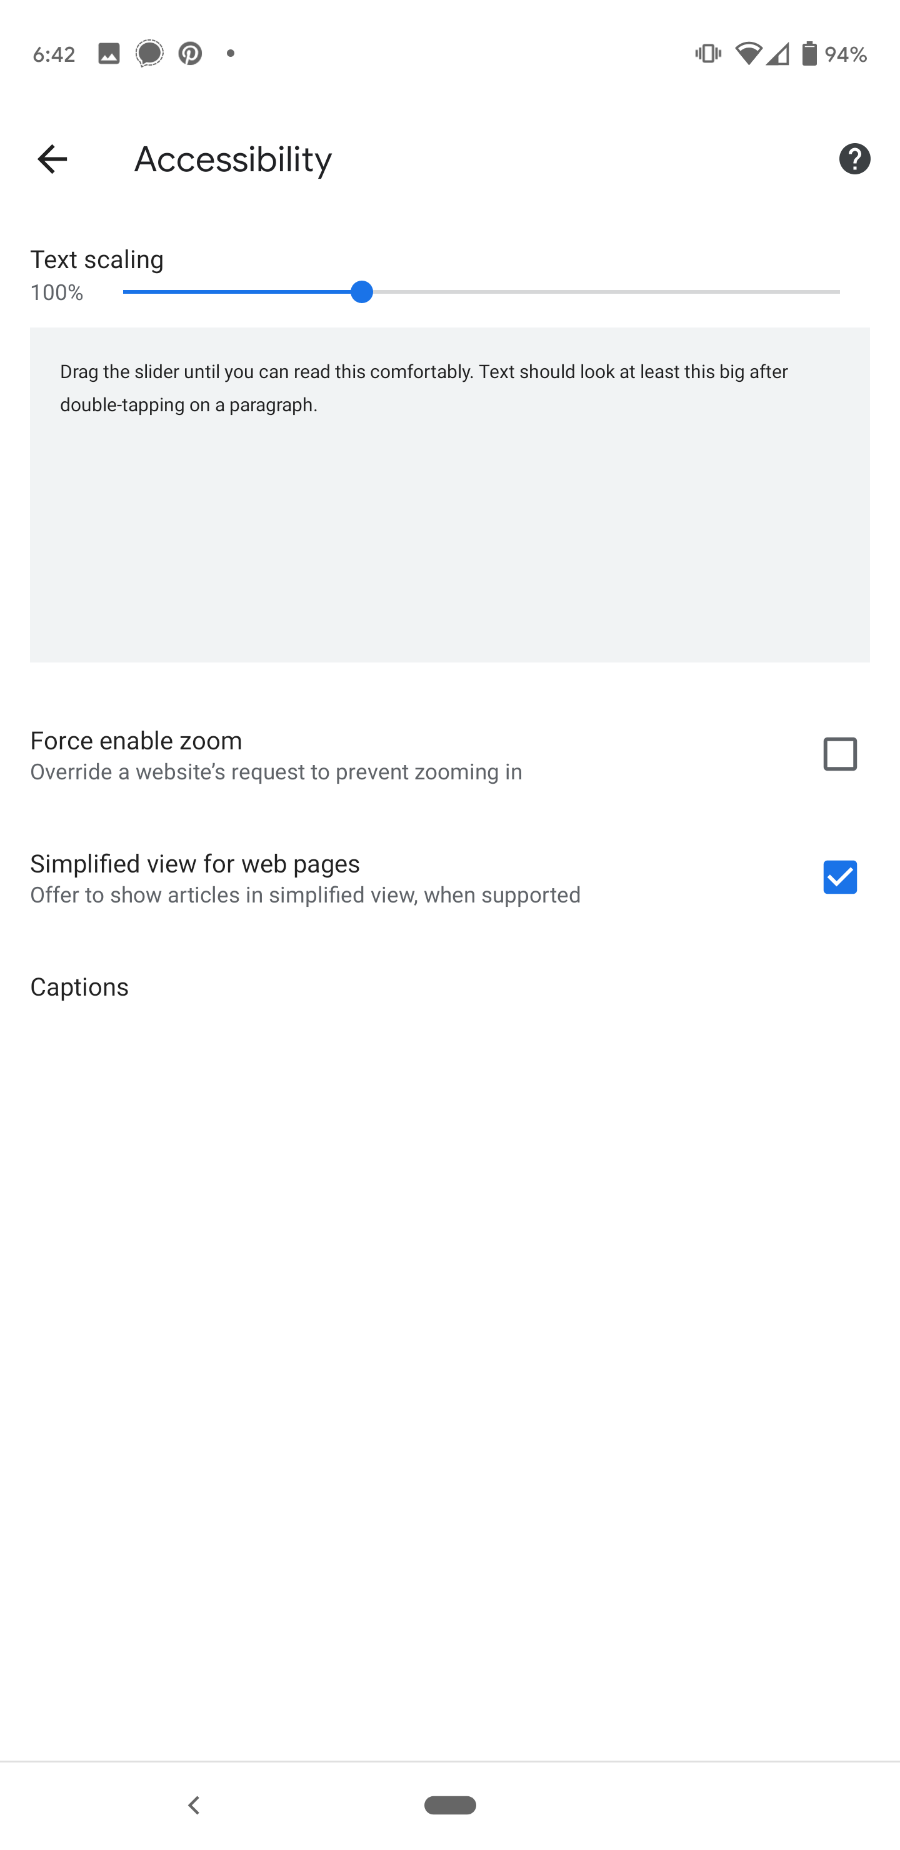

### How to test

1. Open the **Chrome browser** and review the site
2. Change the text size to 200%
3. Does all text content increase in size?
4. Does all the content in the browser reflow accordingly, without obscuring any other non-text elements?

### Examples

#### Pass 1 - All text increases in size

In the ABC website all the text increases.

|  |  |
| --- | --- |
| Figure 66: All text increases in size (normal text size)  Screenshot of a news article with default text size. | Figure 67: All text increases in size (200% text size)  Screenshot of a news article with larger text. |

## 10.11: Simplified view

All actionable items and content can be accessed and activated with Simplified View enabled on Android Chrome.

### About this requirement

To turn on Simplified view on Android Chrome you need to navigate to Chrome and activate the vertical ellipsis in the top right corner. Select **Settings** and then **Accessibility**. Select the option “Simplified view for web pages”. When a simplified view of a page is available it will appear at the bottom of the screen.

Figure 68: Vertical ellipsis menu button in Chrome

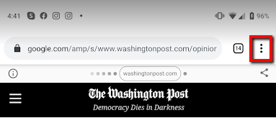

Drop-down menu once the vertical ellipsis has been selected:

Figure 69: Chrome dropdown menu

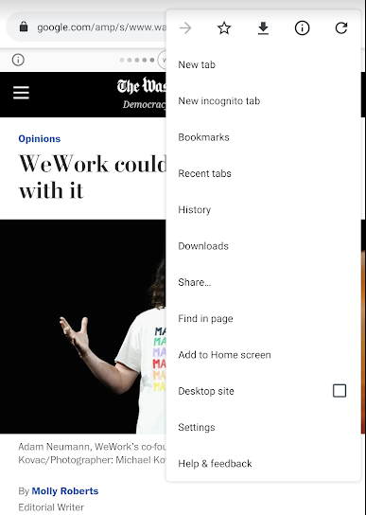

|  |  |
| --- | --- |
| Article on San Francisco Chronicle with simplified view option visible at the bottom of the screen:  Figure 70: "Show simplified view" option  Screenshot showing a San Francisco chronicle web article with a "Show simplified view" button at the bottom. | The simplified view of the article:  Figure 71: Simplified view activated  Screenshot showing a San Francisco chronicle web article in simplified view.  The extra social media icons are missing, and the header and menu are missing. |

### How to test – Android Chrome

1. Open the **Chrome browser** on Android
2. Identify all pages with one main block of text.
3. Increase the text size to 200%.
4. Does the text change size appropriately?
5. Ensure that extraneous content is not shown, and the only content visible is the main block of content (with headings)
6. Ensure the text does not overlap or obstruct other elements on the page.

### Examples – Simplified view (Android)

#### Pass 1 – Simplified view

The New York Times supports Simplified View. With Simplified View enabled the navigation, header, login and subscribe information is removed from the screen.

|  |  |
| --- | --- |
| Normal View | Simplified View |
| Figure 74: Simplified view available (normal view)  Uber article in normal size | Figure 75: Simplified view available (activated)  Same article with navigation, login and other extraneous content removed |

#### Pass 2 – Simplified view

In the Travel Codex website, the Simplified view removes the header and advertisement.

|  |  |
| --- | --- |
| Normal view | Simplified view |
| Figure 76: Simplified view available (normal view)  Screenshot of Travel Codex article in normal view. | Figure 77: Simplified view available (activated)  Screenshot of Travel Codex article in simplified view. |

#### Pass 3 – Simplified view can be used

In the Air and Space website, the ad is underneath the Simplified view so that users can still access the ad and the Simplified view option.

|  |  |
| --- | --- |
| Figure 78: Simplified view can be used  Screenshot of the Smithsonian National Air and Space Museum homepage. A "Show simplified view" button is at the bottom, on top of a popup survey link. The survey link is still accessible. |  |

# Samsung test cases

## 7.1: Voice assistant for Samsung (Samsung)

All actionable items and content can be accessed and activated by Voice Assistant on Samsung.

### About this requirement

Samsung devices include a built-in screen reader called “Voice Assistant,” however TalkBack can still be installed as part of the Accessibility Suite (found in the Google Play Store). Voice Assistant can be activated by accessing Settings → Accessibility → Screen Reader → Voice Assistant.

### How to test

1. With Voice Assistant on, open a web page.
2. Swipe through the site.
3. As you swipe, the content will be read out loud.
4. Verify that all content can be read by Voice Assistant and that the text being read by Voice Assistant matches what is on screen.
5. Verify that all actionable items can be accessed and controlled by Voice Assistant. It is imperative that al actionable items are accurately labelled and described.

### Examples

#### Pass

There are currently no example passes documented for this requirement.

# Kindle test cases

## Help for Kindle

Kindle Fire devices include an Accessibility User’s Guide, located by swiping down from the top of the screen to open Quick Settings. Then navigate to Settings → Accessibility → Accessibility User’s Guide. The User’s Guide includes information for VoiceView, screen magnification, braille displays, and subtitles. Accessibility help can also be found on the amazon website at <https://www.amazon.com/gp/help/customer/display.html?nodeId=201829310&OpenInBrowser=1>

## 12.1: VoiceView for Kindle (Kindle)

All actionable items and content can be accessed and activated by VoiceView on Kindle.

### About this requirement

Kindle Fire devices include a built-in screen reader called "VoiceView". To enable VoiceView, swipe down from the top of the screen to open Quick Settings. Then navigate to Settings → Accessibility → VoiceView Screen Reader, and check VoiceView. A tutorial will be started at the first launch of the screen reader.

### How to test

1. With VoiceView on, open a web page in the Silk browser.
2. Swipe through the mobile site.
3. As you swipe, the content will be read out loud.
4. Verify that all content can be read by VoiceView and that the text being read by VoiceView matches what is on screen.
5. Verify that all actionable items can be accessed and controlled by VoiceView. It is imperative that all actionable items are accurately labelled and described.

### Examples

#### Pass 1 - Content read by VoiceView

In the content of the browser, each finger swipe by the user focuses on an area of the page and reads that area out loud.

|  |  |
| --- | --- |
| Figure 79: Content read by VoiceView  A screenshot of a kennedy-center.org webpage. Text along the top of the screen reads "The VoiceView screen reader is on. Triple-press the power button to turn VoiceView off." |  |

# Acknowledgements

## Relationship to existing Accessibility testing standards

This document is based on:

* W3C Web Content Accessibility Guidelines, Version 2.0
* W3C Web Content Accessibility Guidelines, Version 2.1
* BBC Mobile Accessibility Guidelines
* AccessibilityOz Mobile Testing Methodology
* TPG Mobile Testing Guide

## ICT Accessibility Testing Symposium Mobile Site Sub-Committee

This document was developed by the ICT Accessibility Testing Symposium Mobile Sub-Committee. Members include: Gian Wild (Co-Chair), Peter McNally (Co-Chair), Brent Davis, Corbb O'Connor, Karen Herr, Kathryn Weber-Hottleman, Kathy Eng, Laura Renfro, Megha Rajopadhye, Mona Rekhi, Morgan Lee Kestner, Rafal Charlampowicz, Ryan Pugh, Steve Sawczyn, Sunish Gupta, Tom Lawton and Chris Law.

# Contacts

## Gian Wild

**Web:** [www.accessibilityoz.com](http://www.accessibilityoz.com)

**Phone:** 415 621 9366

**Email:** [gian@accessibilityoz.com](mailto:gian@accessibilityoz.com)

## Peter McNally

**Web:** [www.bentley.edu](http://www.bentley.edu)

**Phone:** 781 891 2893

**Email:** [pmcnally@bentley.edu](mailto:pmcnally@bentley.edu)